Agile Project Planning for a Library Management System

Dinesh Devkota
Modern Institute of Technology (MIT)
CSE220: Principles Of Software Engineering
Professor Poshan Karki
July 10, 2026

Introduction
- Project Background
Library Name: ABC Public Library
ABC Public library is a medium size community library in Kathmandu, Nepal. The library has an approximate membership of 2500 students, teachers and the public. The library currently has a partially manual book-keeping system to keep track of books, member registration, and borrowing. These manual methods have several drawbacks, including delays, mismanagement of records, and decreased operational efficiency (Pressman & Maxim, 2020).
- Problem
The library uses manual records to check out books, return books and to keep records of members. This makes it more likely for books to get lost, records to go astray, and for people to overlook books they've borrowed. Librarians spend considerable time on repetitive administrative tasks which can be automated by software solution. Library Management System implementation would result in greater efficiency, error reduction and better services to the library users (Pressman & Maxim, 2020).
- Project Scope
The Library Management System is designed to streamline library operations and automate various tasks by implementing the following features:
- User Authentication (Login)
- The registration and management of members. Registration of members and member management.
- Book Catalog Management
- Book Search
- Book Issue and Return
- Automatic Fine Calculation
- Report Generation Out of Scope
The current project does not include the following features:
- Online Payment Integration
- Mobile Application
- AI-Based Book Recommendation
- Barcode/RFID Integration
The project will be developed with the Scrum Agile methodology, and managed in two two-week development sprints. Scrum promotes small, incremental software releases and allows and provides feedback from customers throughout the development process (Schwaber & Sutherland, 2020).
- Stakeholders
Primary Stakeholders
Library Members: Be able to search, borrow books and return them efficiently.
Librarians: Check out/return books, membership, book return, and book management. Secondary Stakeholders
Library Administrator: Looks over reports and oversees the library.
IT Administrator: Responsible for keeping the system, database and software running efficiently.
- Selected Agile Methodology
It was decided to use Scrum as it enables iterative development, collaboration and continuous improvement through short time periods called sprints. Scrum allows teams to be responsive to changing requirements and also provide functional software at the end of each sprint. Besides this, Scrum is supported by project management tools like Trello, which gives transparency in assignments, backlog, and tracking sprints (Schwaber & Sutherland, 2020). The principles of the Software Engineering Code of Ethics (Gotterbarn et al., 1999) will also guide the development team in this project and make sure they are professional, of high quality, accountably and responsibly in the software development process.
Agile Project Plan
- Product Backlog
- Sprint Planning
- Task Cards
- Trello Workflow
The Trello board was organized using the following workflow:
Product Backlog → Sprint 1 → Sprint 2 → In Progress → Testing → Done
Execution Simulation
The methodology chosen for the project implementation of Library Management System project was Scrum Agile. The project was split into two 2 week sprints. The product backlog was kept and maintained in Trello, sprints were managed and the progress of sprints was monitored in Trello (Schwaber & Sutherland, 2020).
- Sprint Planning
In Sprint Planning, the Product Owner ordered the product backlog items and the development team chose the user stories according to the estimated effort and importance.
Sprint 1: Login, Book Management, Book Search, and Member Registration.
Sprint 2: Book Issue, Book Return, Fine Calculation and Report Generation.
The tasks were all estimated for their workload by assigning story points (Pressman & Maxim, 2020).
- Task Assignment
Tasks were assigned to team members based on their roles and expertise.
Role | Responsibility
Product Owner | Prioritized the product backlog and defined project requirements.
Scrum Master | Facilitated Scrum meetings, monitored sprint progress, and removed obstacles.
Developers | Developed the assigned modules, implemented user stories, and fixed reported issues.
Tester | Performed functional testing, identified bugs, and verified completed features before deployment.
- Daily Stand-up Meetings
Stand up meetings were held every day to review project progress.
Finished: Login and Book Management modules.
In Progress: Book search, Member Registration.
Few minor issues related to database connectivity were identified as blockers, and thus were resolved quickly.
These meetings benefited in communicating and monitoring the progress of the sprints (Schwaber & Sutherland, 2020).
- Sprint Review
Features built in each sprint were shown to stakeholders at the end of the sprint.
Sprint 1: Logon, Book Management, Book Search, and Member Registration.
Sprint 2: Book Issue, Book Return, Fine Calculation and Report Generation.
The next sprint was based on stakeholder feedback.
- Sprint Retrospective
Team viewed the sprint and discussed strengths and areas for improvement.
Strengths
Good teamwork and communication
Work completed on time.
Effective use of Trello
Areas for Improvement
Better effort estimation
Earlier testing
Greater task planning in detail
One of the main values of the Scrum family of values is continuous improvement (Schwaber & Sutherland, 2020).
Trello Screenshots
- Trello Board Setup (Product Backlog, Sprint 1, Sprint 2, In Progress, Testing, Done)
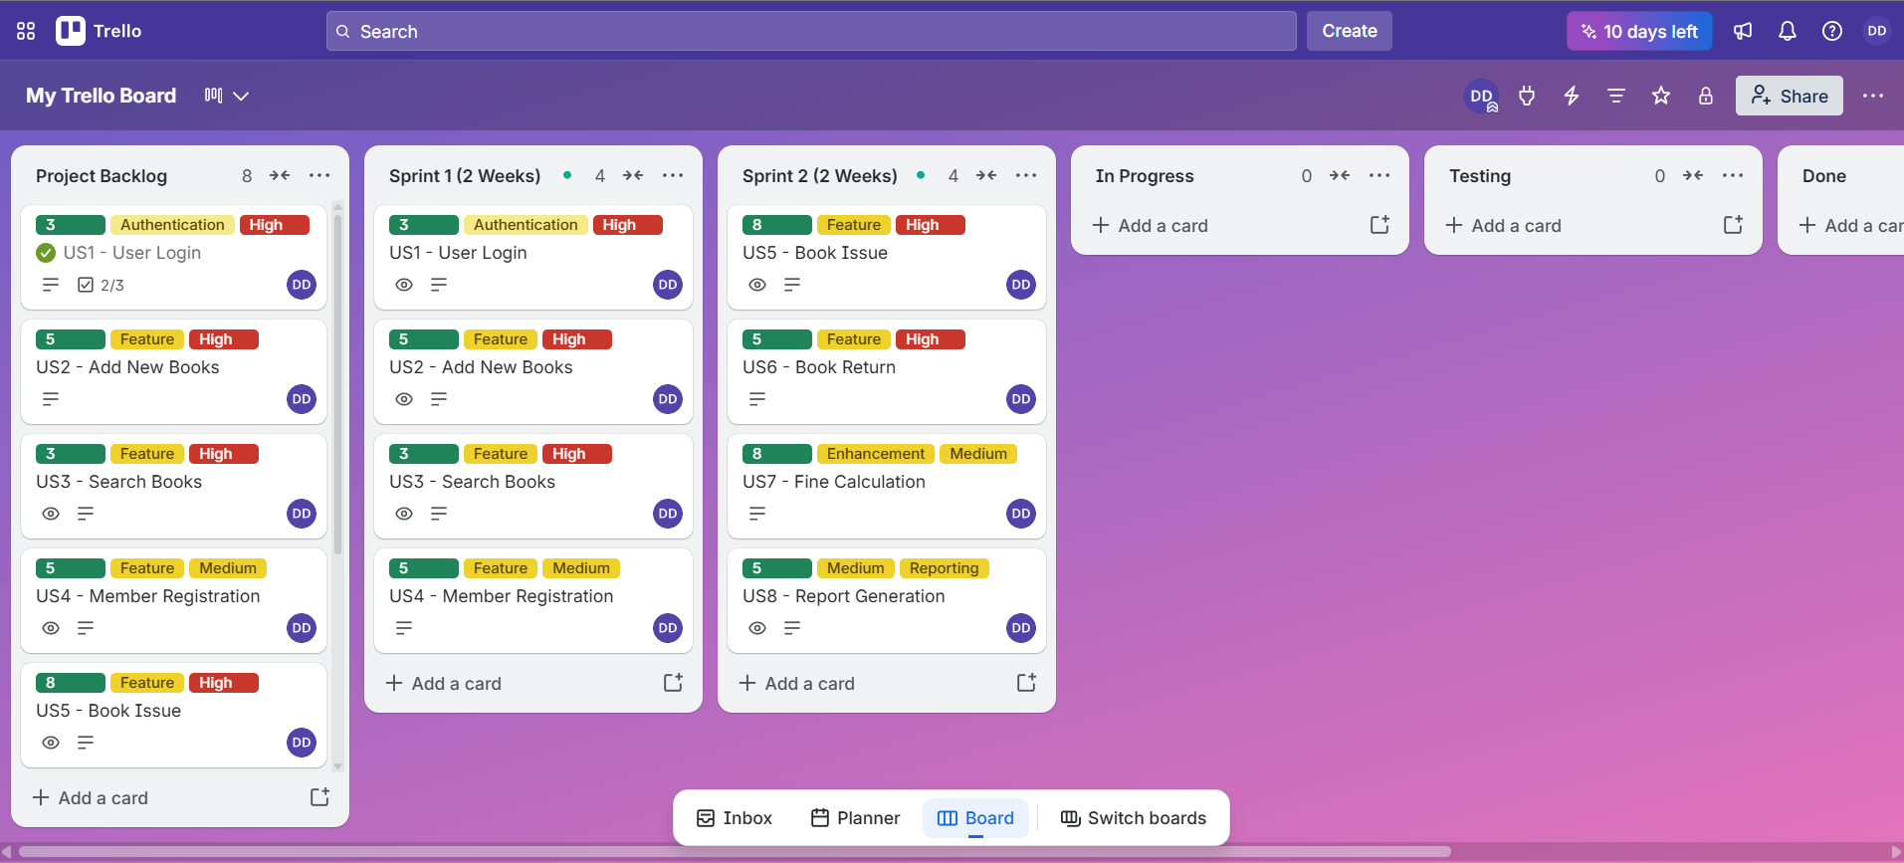
Figure 1
Trello Board Setup (Product Backlog, Sprint 1, Sprint 2, In Progress, Testing, Done)

- Sprint 1 Progress (Task Moving from To Do to In Progress to Done)
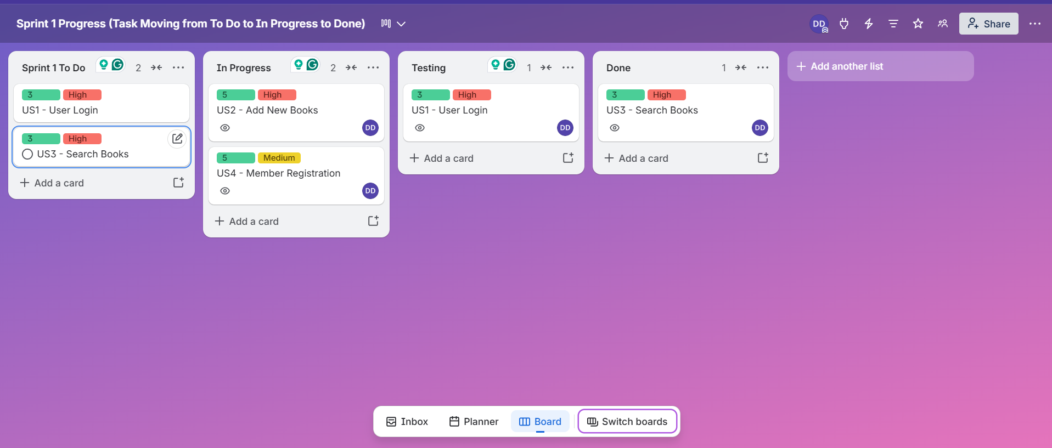
Figure 2
Sprint 1 Progress (Task Moving from To Do to In Progress to Done)

- Sprint 2 Progress (Progress and Complete tasks)
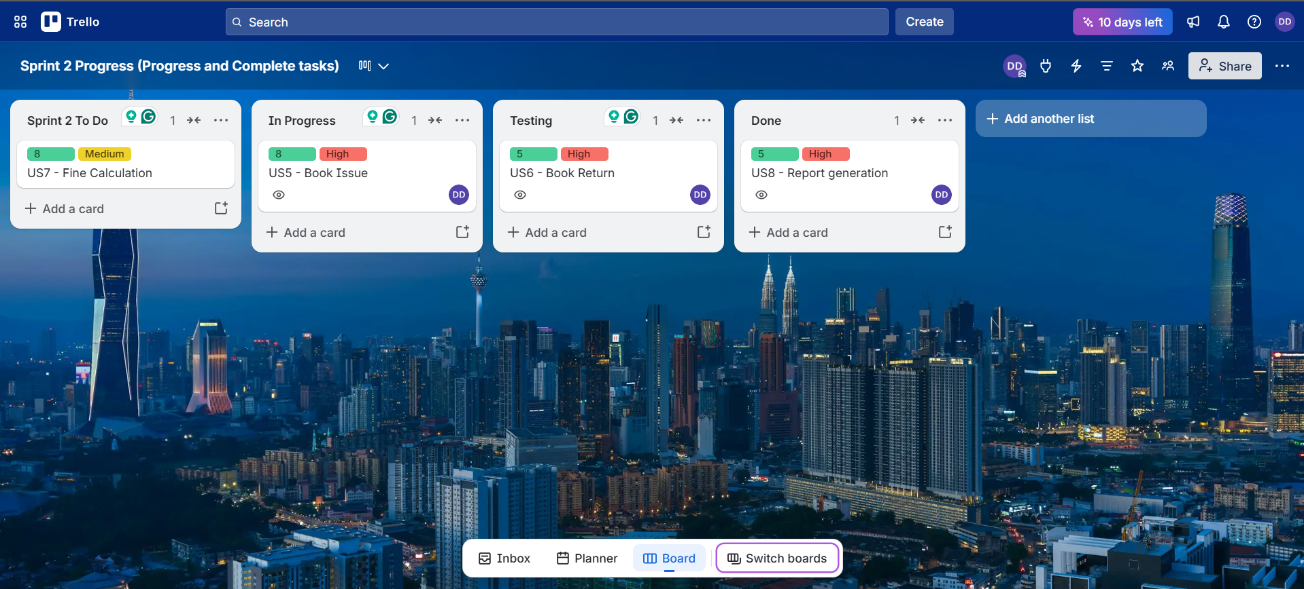
Figure 3
Sprint 2 Progress (Progress and Complete tasks)
Comparison of Scrum and XP
Feature | Scrum | Extreme Programming (XP)
Focus | Project Management | Software Development Practices
Sprint | Yes | Yes
Pair Programming | No | Yes
Continuous Integration | Optional | Required
Customer Involvement | Regular Reviews | Continuous
Best For | Medium & Large Projects | Small Teams

Discussion
Scrum concentrates on managing project activities with sprints, planning, and review meetings which are suitable for organizing work and tracking progress. XP advocates engineering principles like pair programming, test driven development, and continuous integration to promote high quality software. The implementation of Scrum in this project was chosen because Trello provides a good way to track sprint planning, backlog, and tasks.
Reflection
Working on the project through Scrum and Trello gave a hands-on experience with Agile Software Development. Dividing the project into smaller sprints helped with task management and for the team to focus on attainable goals. By providing a visual overview of project progress and making it easy for all members of the team to see which tasks are complete, Trello made collaboration a more enjoyable and efficient experience. The workload estimation was made easier with the use of story points and communication and quick resolution of issues was promoted through daily stand up meetings. In conclusion, Scrum was successful in managing the project of Library Management System.
Conclusion
The Library Management System project is a good example of the use of Scrum to plan and manage software development. The team had the ability to adapt to feedback during the project by organising their work into product backlogs and sprints, allowing them to make steady progress. Trello has improved visibility and collaboration, and Agile has enabled quick delivery and ongoing improvement. In this simulation, students will learn about the advantages of Agile methodologies in the development of a reliable software system.

References
Gotterbarn, D., Miller, K., & Rogerson, S. (1999). Software engineering code of ethics. Communications of the ACM, 42(10), 102–107. https://doi.org/10.1145/317665.317682
Pressman, R. S., & Maxim, B. R. (2020). Software engineering: A practitioner's approach (9th ed.). McGraw-Hill Education.
Schwaber, K., & Sutherland, J. (2020). The Scrum Guide: The definitive guide to Scrum: The rules of the game. Scrum Guides. https://scrumguides.org/docs/scrumguide/v2020/2020-Scrum-Guide-US.pdf

